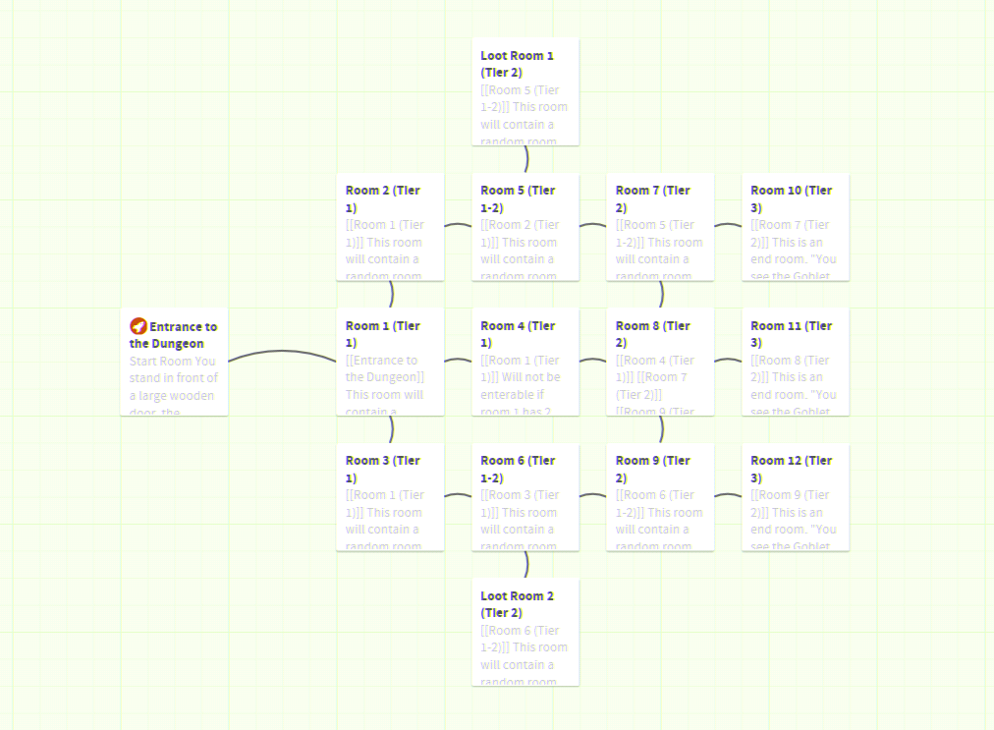

|  |  |  |
| --- | --- | --- |
| **Room Name**  **Index** | **Content of Room** | **Choices (Where choice leads)**  **Index of Choice** |
| Entrance  0 | You stand in front of a large wooden door, the entrance to the dungeon of Death. Inside you may find wealth, fame, danger or death. You goal is to reach the chamber of Salomon, and claim the Goblet of Life.  The Dungeon of Death is a randomly generated dungeon crawler. Every room you enter inside will be randomly generated and contain a random number of objects. Best of luck on your quest. | Selection 1: Open the door and enter the dungeon.  Index 1 |
| Room 1  1 | This room will contain a random room layout.  It may contain 1 monster from Tier 1 Selection.  It will not contain any loot.  Will have between 2 and 3 doors. | Selection 1: Door 1 (Room 2)  Index 2  Selection 2: Door 2 (Room 3)  Index 3  Selection 3: Door 3 (Room 4)  Index 4 |
| Room 2  2 | This room will contain a random room layout.  It may contain 1 monster from Tier 1 Selection.  It may contain low level loot.  Has 2 doors. | Selection 1: Back to Previous Room  Index 1  Selection 2: Door 1 (Room 5)  Index 5 |
| Room 3  3 | This room will contain a random room layout.  It may contain 1 monster from Tier 1 Selection.  It may contain low level loot.  Has 2 doors. | Selection 1: Back to Previous Room  Index 1  Selection 2: Door 1 (Room 6)  Index 6 |
| Room 4  4 | Will not be enterable if room 1 has 2 doors.  This room will contain a random room layout.  It may contain 1 monster from Tier 1 Selection.  It may contain low level loot.  Has 2 doors. | Selection 1: Back to Previous Room  Index 1  Selection 2: Door 1 (Room 8)  Index 8 |
| Room 5  5 | This room will contain a random room layout.  It may contain 2 monsters from Tier 1 or Tier 2 Selection.  It may contain low level loot.  May have up to 3 doors. | Selection 1: Back to Previous Room  Index 2  Selection 2: Door 1 (Room 7)  Index 7  Selection 3: Door 2 (Loot Room 1)  Index 13 |
| Room 6  6 | This room will contain a random room layout.  It may contain 2 monsters from Tier 1 or Tier 2 Selection.  It may contain low level loot.  May have up to 3 doors. | Selection 1: Back to Previous Room  Index 3  Selection 2: Door 1(Room 9)  Index 9  Selection 3: Door 2 (Loot Room 2)  Index 14 |
| Room 7  7 | This room will contain a random room layout from Tier 2 Selection.  It may contain 2 monsters from Tier 2 Selection.  It may contain low - mid level loot.  May have up to 3 doors. | Selection 1: Back to Previous Room  Index 5  Selection 2: Door 1 (Room 8)  Index 8  Selection 3: Door 2 (Room 10)  Index 10 |
| Room 8  8 | This room will contain a random room layout.  It may contain 2 monsters from Tier 2 Selection.  It may contain low level loot.  May have up to 4 doors. | Selection 1: Back to Previous Room  Index 4  Selection 2: Door 1 (Room 7)  Index 7  Selection 3: Door 2 (Room 9)  Index 9  Selection 4: Door 3 (Room 11)  Index 11 |
| Room 9  9 | This room will contain a random room layout.  It may contain 2 monsters from Tier 2 Selection.  It may contain low - mid level loot.  May have up to 3 doors. | Selection 1: Back to Previous Room  Index 6  Selection 2: Door 1 (Room 8)  Index 8  Selection 3: Door 2 (Room 12)  Index 12 |
| Room 10  10 | This is an end room. "You see the Goblet of Life stood on an Altar before you. Behind it stands a statue to the god Zeus. You pick up the goblet and take a sip, and you feel power rushing through your veins, and you lift your sword and pack with renewed ease. Somehow, your way out will not be as hard as the way in."  Adventure ends and win screen appears. Option to start again. | End Screen 15  Or back to previous Room  Index 7 |
| Room 11  11 | This is an end room. "You see the Goblet of Life stood on an Altar before you. Behind it stands a statue to the god Zeus. You pick up the goblet and take a sip, and you feel power rushing through your veins, and you lift your sword and pack with renewed ease. Somehow, your way out will not be as hard as the way in."  Adventure ends and win screen appears. Option to start again. | End Screen 15  Or back to previous Room  Index 8 |
| Room 12  12 | This is an end room. "You see the Goblet of Life stood on an Altar before you. Behind it stands a statue to the god Zeus. You pick up the goblet and take a sip, and you feel power rushing through your veins, and you lift your sword and pack with renewed ease. Somehow, your way out will not be as hard as the way in."  Adventure ends and win screen appears. Option to start again. | End Screen 15  Or back to previous Room  Index 9 |
| Loot Room 1  13 | This room will contain a random room layout from Loot Room Selection.  It will contain 1-3 monsters from Tier 2 Selection.  It may contain high level loot, but will contain low or mid-level loot.  Only has 1 Door. | Selection 1: Back to Previous Room  Index 5 |
| Loot Room 2  14 | This room will contain a random room layout from Loot Room Selection.  It will contain 1-3 monsters from Tier 2 Selection.  It may contain high level loot, but will contain low or mid-level loot.  Only has 1 Door. | Selection 1: Back to Previous Room  Index 6 |
| End Screen  15 | End Screen Shows stats such as loot collected, Enemies killed, number of rooms visited and enemies avoided. | Start again  Index 0  Close |

Room Layout Random Text:

Part 1 - ("You are in a small brick room", "You are in a small tiled room", "You are in a small room with a tall ceiling", "You are in a medium sized room with brick walls", "You are in a medium tiled room",

"You are in a large sized room with brick walls", "You are in a large sized room with tiled walls", "You are in a long but narrow room", "You are in a wide room")

Part 2 - (", with several regal banners hanging off the walls.", ", which is poorly lit.", ". There is a large table in the middle of the room.", ". A window is set in the wall to the left.", ". A window is set in the wall to the right.",

". Several of the floor tiles have fallen away, revealing a deep abyss below you.", ", and several startled rats run away from you.")

Part 2 is attached to part 1 and displayed as the room i.e. "You are in a small brick room, with several regal banners hanging off the walls.")

Monsters:

Tier 1 Monsters: Goblin, Guard, Orc, Giant Spider.

Tier 2 Monsters: Orc War boss, Daemon, Manticore, Dragon, Owlbear.

Combat will be resolved using an equipment counter system. Some items will counter all monsters of a certain kind, such a sword will kill all goblins. However, some items are numbered use only, such as armour which can take a certain number of hits. If the player cannot counter an enemy, it will deal a point of damage to them. This can be absorbed by armour, or it will kill them.

There are 3 item types: Armour, Weapon and Magical.

Armour: Negates damage from any enemies you cannot counter.

Weapon: Counters a certain type of creature. Can be single use or multiple use.

Magical: Have special abilities such as defeating multiple creatures or reviving you after a death.

Players can choose 4 items before they enter the dungeon. Once in the dungeon, they may collect any items that are lying around as loot.

Item Table

|  |  |  |
| --- | --- | --- |
| **Item Name** | **Description and ability** | **Number of Uses** |
| **Armours:** |  | **0 == unlimited** |
| Plate Armour | Strong layered plate armour that absorbs damage. Can take 2 damage before being destroyed. | 2 |
| Shield | A sturdy shield that can be used to block any incoming attacks. Can take 1 damage before being destroyed. | 1 |
|  |  |  |
| **Weapons** |  |  |
| Sword | A strong iron sword, adept at killing lesser beings. Kills Goblins and Guards. | 0 |
| Axe | A rugged battle axe, with a hefty swing. Kills Orcs and Giant Spiders. | 0 |
| Possessed Dagger | A dagger infused with the spirit of a daemon. Kills Daemons and Manticores. | 1 |
| Draconic Spear | A spear made from the bone and teeth of a dragon, infused with magical power. Kills Dragons. | 2 |
| Rune Axe | An ancient dwarven axe infused with magical power by ancient runes. Kills Orc War bosses and Owlbears. | 1 |
|  |  |  |
| **Magical** |  |  |
| Potion of Healing | A magical potion of unknown origin, sold to you by an old mage. Revives the player when they die. When used, room is cleared automatically. | 1 |

Loot:

Low - An old sword, 10 gold pieces, a collection of rocks, a goblin helmet.

Medium - A finely crafted axe, 100 gold pieces, a glittering gemstone, a shield.

High - A chest filled with 1000 gold pieces, a diamond, a ancient sword instilled with great magical power,.

End Rooms:

End rooms: Only one of the end rooms will complete the adventure. The other 2 rooms will be either empty dead ends or loot rooms.

Art Assets:

For the background I have used an image from:

<http://www.publicdomainpictures.net/view-image.php?image=191224&picture=brick-wall-background-texture>

with slight modifications (Blurring, old painting effect)

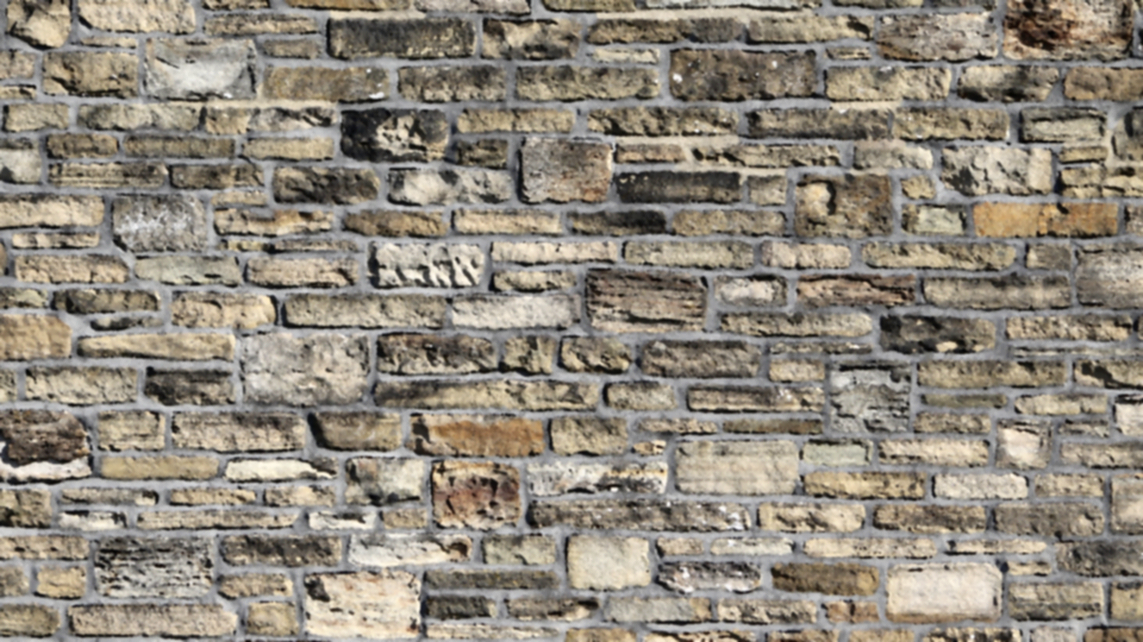

This is not all the art I will be using, but it is the only part implemented so far.